1. Query : **45.127.223.83**

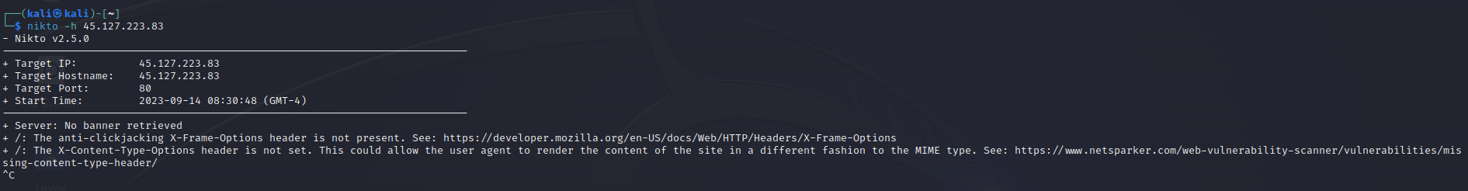

2. **43.205.128.56**

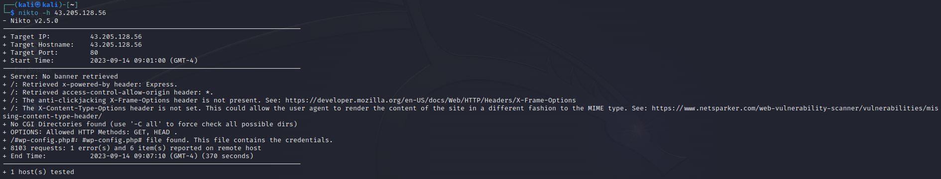

# 3.164.52.196.34

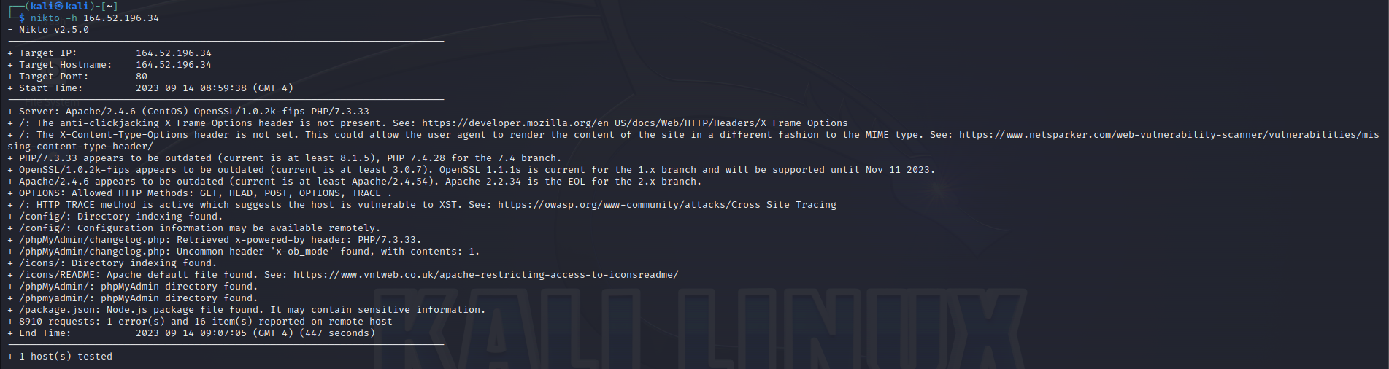

4. **103.120.178.71**

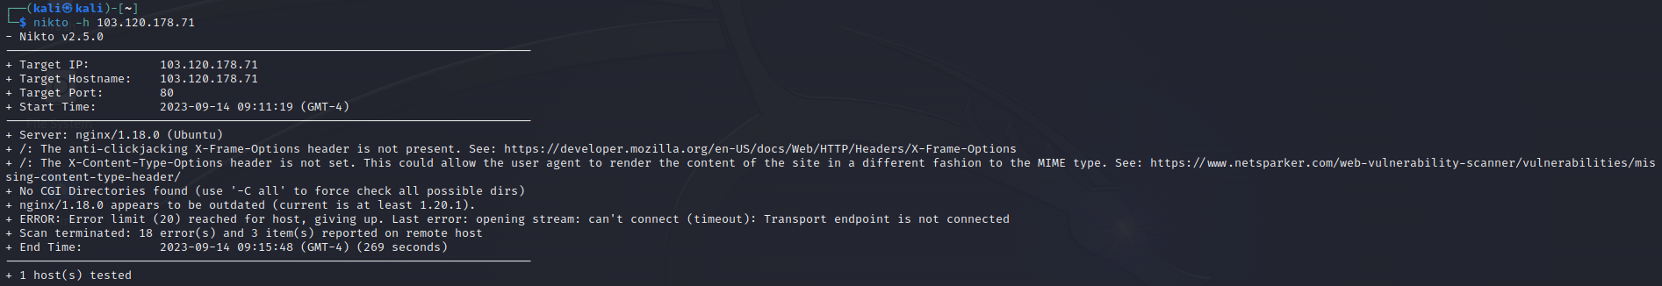

5. **122.184.72.206**

<http://122.184.72.206:8001/>

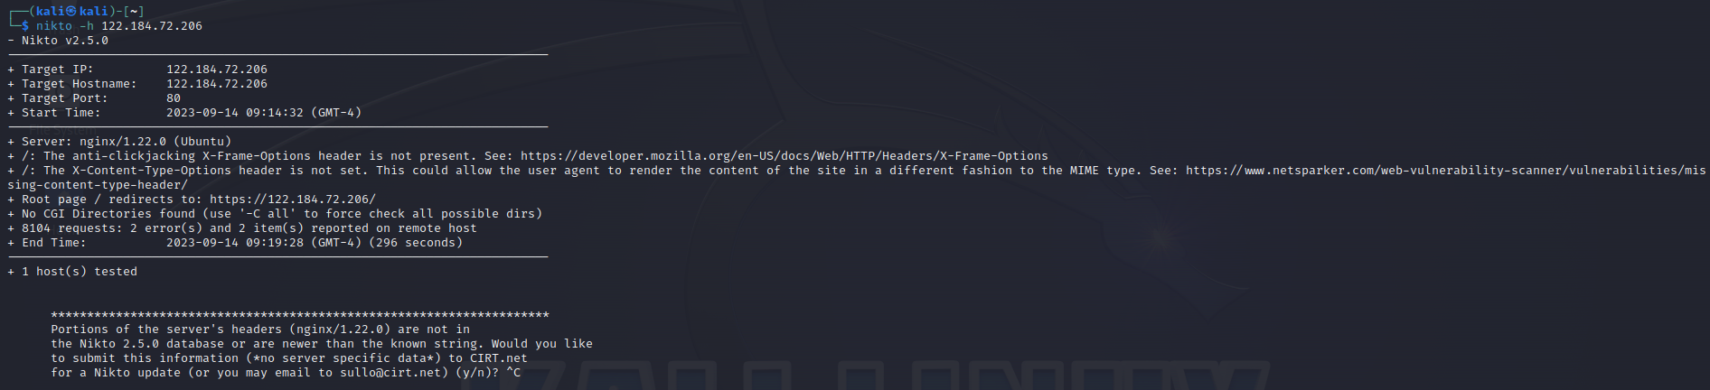

6. **157.245.101.18**

<http://157.245.101.18/>

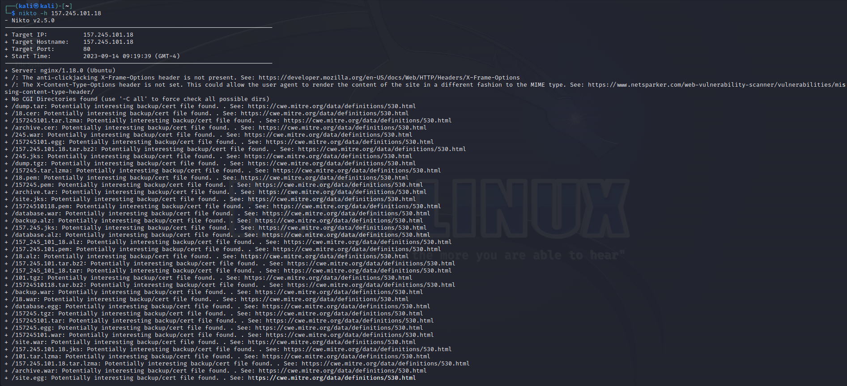

7. **13.235.155.128**

<http://13.235.155.128:443/#/home>

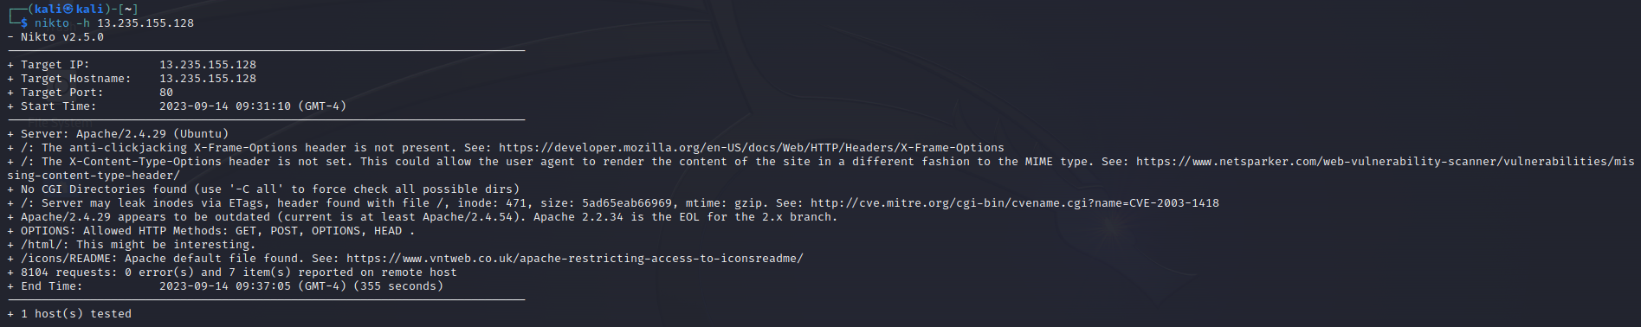

8 .**139.59.65.209**

<http://139.59.65.209:5001/>

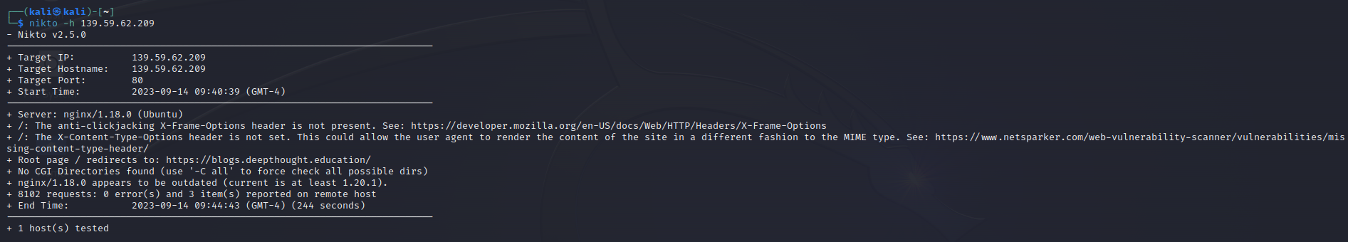

9. **103.104.73.187**

<http://103.104.73.187:7001/>

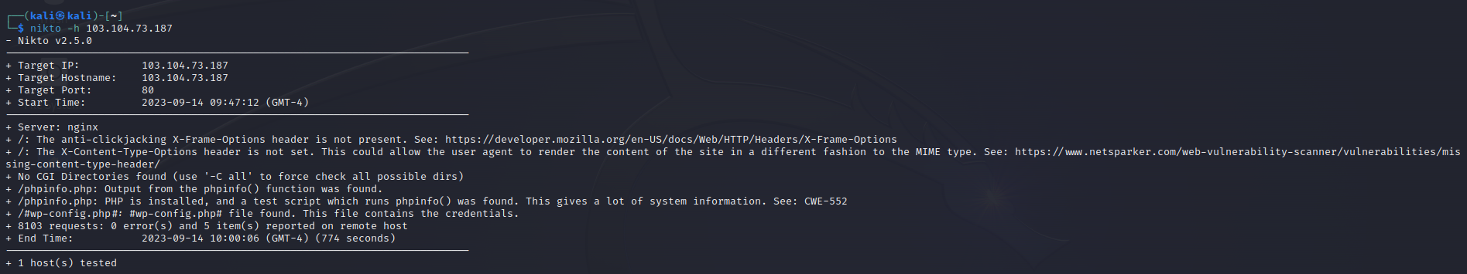

10.**13.234.161.48**

<http://13.234.161.48:3001/>

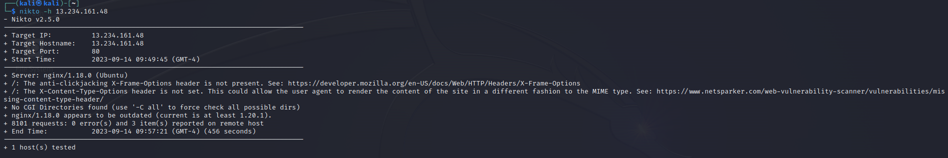

11. **15.207.136.28**

<http://15.207.136.28:443/>

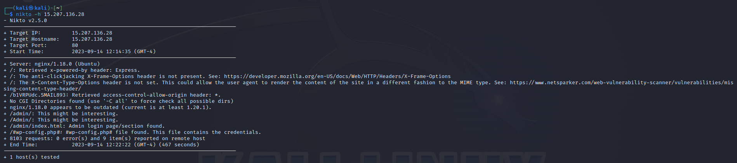

12.**139.59.41.108**

http://139.59.41.108:8081/



 